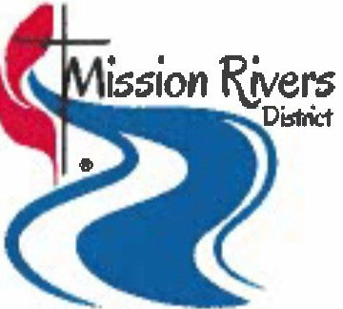
Mission Rivers District Mission Grant Application
The vision of the Mission Rivers District Committee on Missions is to encourage and assist individuals/ groups to reach into their communities to make disciples of Jesus Christ for the

This form and attachments must be received by the District Office on or before May 15, 2026. YOU MUST CONFIRM RECEIPT WITH THE DISTRICT OFFICE BY THAT TIME.

Date:
Project Name: Organization Name:
Organization Website:
Mailing Address:
Address Line 1

Address Line 2

City State Zip Code

Required Signatures

Church Organization:
Church Council/ Administrative Council Chair:

Printed Name Signature

Senior Pastor:

Printed Name Signature

1

Non-Church Organization:

Executive Officer or Director:

Printed Name Signature

Chair, Governing Board:

Printed Name Signature

Is this project new or on-going? New On-going If on-going, how long?
Location of Project?

Who are the key leaders?

 | Name |  |  | Phone |  |  | Email
 | Name |  |  | Phone |  |  | Email

Amount of this request:
Scheduled date of completion:
What other funding sources, other than this grant are you using?

The Mission Rivers District Committee on Missions does not reimburse for projects completed and paid for.

Have you received a grant from the York River District Board of Missions or Rappahannock River District or Mission Rivers District previously? Yes No

If yes, then how many years have you received District Board of Missions funds? (complete table below)

Year | Name of Project/Program | Amount

Mark the Characteristics of the Vital Congregations that fit your request for a grant:
- Worship
- Mission
- Evangelism
- Stewardship
- Discipleship

Attach the following documents for each application:

- 2024 Audit or equivalent
- 2026 Current Year Church/Non-church organization Budget
- Spending to date for on-going programs/ projects
- 2026 Projected budget for the program/ project
- Church Organizations: Portion of Church Council (or equivalent) minutes approving application, including date.
- Non-church Organizations: Portion of Governing Board minutes approving application, including date.
Who are you serving? (i.e. demographics of church and community)

The money received from this Grant will be used to help cover cost for the following:

How does your project fit the mission of The United Methodist Church, which is to make disciples of Jesus Christ for the transformation of the world?

How will you measure the effectiveness/success of your program?

All recipients are expected to submit a progress report or a complete report within 30 days of the scheduled completion date of each year's work on their mission/project. When will you prepare your progress report for this grant? (mm/yyyy).

Please state whether your church is current in paying its District Apportionments. If not, explain your extenuating circumstances.

